**Final Report**

**PROJECT TITLE: Sustainable Smart City Assistant Using IBM Granite LLM**

**1. INTRODUCTION**

**1.1 Project Overview**

The Sustainable Smart City Assistant is an AI-powered platform built using IBM Watsonx’s Granite LLM to support urban sustainability, governance, and citizen engagement. It integrates key modules such as KPI forecasting, anomaly detection, document summarization, policy search, feedback collection, eco tips generation, and AI-driven chat into a single dashboard using FastAPI and Streamlit.

**1.2 Purpose**

The assistant aims to modernize urban management by enabling city administrators and citizens to interact with real-time data and AI tools, make informed decisions, and drive sustainability goals.

**2. IDEATION PHASE**

**2.1 Problem Statement**

City management is complex, with fragmented tools for policy interpretation, issue reporting, data analysis, and sustainability planning. This assistant unifies those capabilities into one smart interface.

**2.2 Empathy Map Canvas**

**SAYS:** “How can I report issues or understand policies easily?”  
**THINKS:** “Can AI help forecast and detect problems in advance?”  
**DOES:** Uploads files, submits feedback, chats with AI  
**FEELS:** Empowered, informed, involved  
**PAINS:** Unclear documents, slow issue response, poor data insight  
**GAINS:** Faster reporting, accessible policy summaries, real-time AI answers

**2.3 Brainstorming**

Initial modules (chatbot, anomaly detector, eco advisor, summarizer) were integrated into a single unified assistant with a modular backend and AI-enhanced frontend.

**3. REQUIREMENT ANALYSIS**

**3.1 Customer Journey Map**

1. Visit dashboard
2. Upload document or data
3. Choose a module: summary, feedback, forecasting, etc.
4. Receive output (summary, tip, forecast, anomaly alert, report)
5. Download or interact further

**3.2 Solution Requirements**

a) Upload documents/data (TXT, CSV)  
b) Submit real-time feedback  
c) Get AI summaries, forecasts, and eco tips  
d) Retrieve reports or interact via chatbot

**3.3 Data Flow Diagram**

(Placeholder: To be created showing interaction between user, frontend, API, LLM, and Pinecone.)

**3.4 Technology Stack**

* **Frontend:** Streamlit
* **Backend:** FastAPI
* **AI Service:** IBM Watsonx Granite LLM
* **ML/Stats:** Scikit-learn (Linear Regression)
* **Vector DB:** Pinecone
* **Embedding Model:** Sentence Transformers (MiniLM)
* **Env Management:** .env, Pydantic

**4. PROJECT DESIGN**

**4.1 Problem–Solution Fit**

Urban planning and engagement require transparency, prediction, and feedback loops. The proposed solution addresses all with a scalable, intelligent system.

**4.2 Proposed Solution**

* **Layer 1:** Streamlit UI for interaction
* **Layer 2:** FastAPI backend for routing and logic
* **Layer 3:** Granite LLM and ML for insights
* **Layer 4:** Pinecone for semantic policy search

**4.3 Solution Architecture**

(Placeholder: A layered architecture diagram showing interaction between UI → API → Granite → Pinecone → Output.)

**5. PROJECT PLANNING & SCHEDULING**

**5.1 Project Planning**

* **Week 1:** Requirements, setup, Streamlit structure
* **Week 2:** Watsonx integration, document summarizer
* **Week 3:** Forecasting, anomaly detection, Pinecone vector search
* **Week 4:** Chat assistant, eco tips, report generator, testing

**6. FUNCTIONAL AND PERFORMANCE TESTING**

**6.1 Performance Testing**

* Unit tests on file uploads, feedback parsing
* API endpoint testing via Swagger
* Edge case handling (empty files, malformed CSV)
* Real-time performance observed via dashboard interaction

**7. RESULTS**

**🧠 Chat with Smart Assistant (Powered by IBM Watsonx Granite)**

* **Functionality:** Users can ask natural language questions related to sustainability, city operations, or climate change.
* **Example:** When a user asks *“How can citizens contribute to a city’s climate goals?”*, the assistant provides actionable tips like reducing energy use, adopting renewable energy, and supporting eco-friendly businesses.
* **Benefit:** Promotes informed citizen engagement through accessible AI insights.

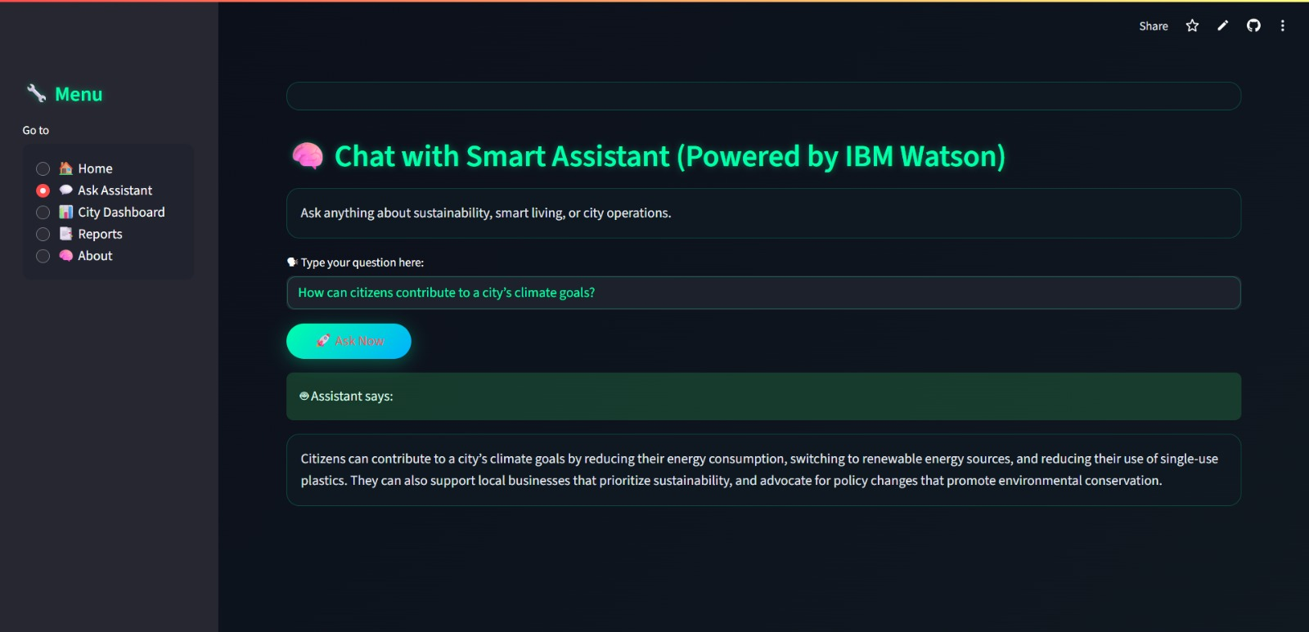

**📊 City Dashboard – Weekly KPI Trends**

* **Functionality:** Displays interactive graphs showing key performance indicators such as air quality, energy usage, water consumption, and waste generation.
* **Feature:** The assistant analyzes trends and provides AI-generated insights below the graphs.
* **Example Insight:** *“Air quality is improving, electricity usage is increasing, water usage is decreasing...”*
* **Benefit:** Empowers city planners to make data-driven decisions based on weekly trends.

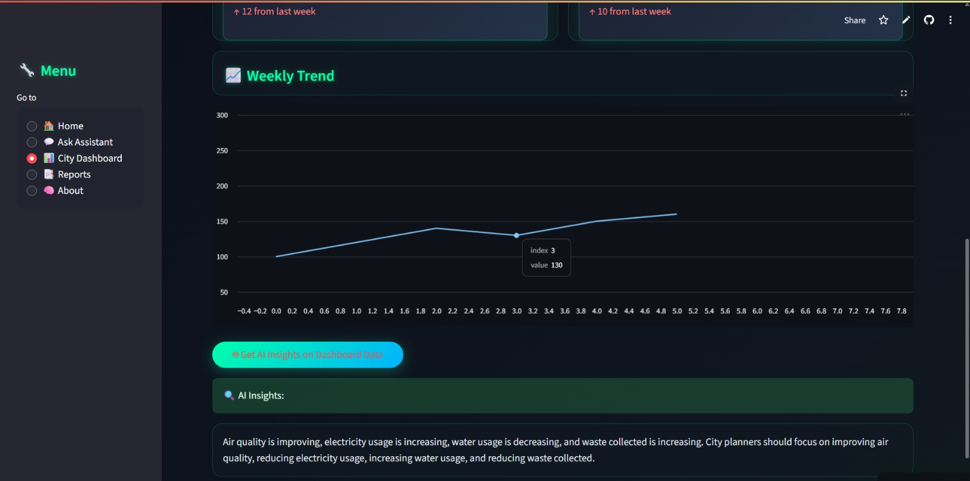

**📄 Sustainability Report Generation**

* **Functionality:** Users can select a date range to generate a comprehensive city sustainability report.
* **Process:** The system analyzes uploaded KPI data and generates a summary with AI assistance.
* **Example Summary:**
  + ✅ Pollution levels are within safe limits
  + ⚡ Power usage increased by 5%
  + 💧 Water usage dropped by 4%
  + 🗑 Waste generation slightly increased
* **Benefit:** Offers data-backed reporting for administrators and policy-makers with options to enhance reports further using AI.

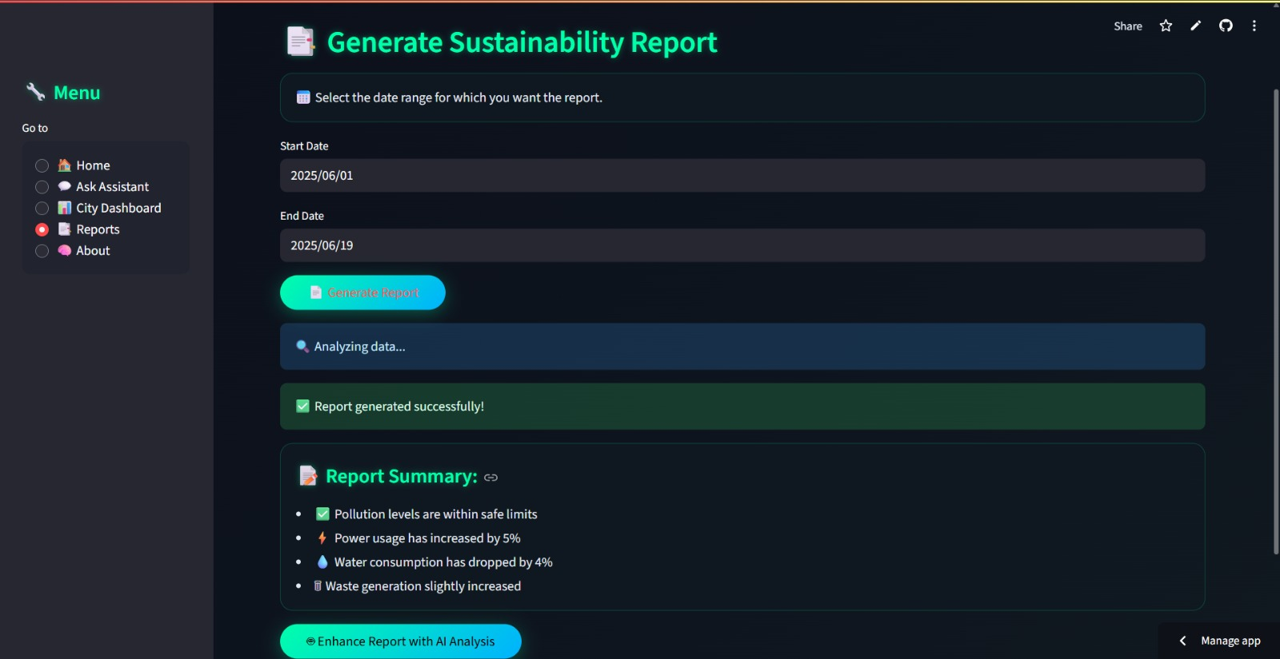

**8. ADVANTAGES & DISADVANTAGES**

**Advantages**

* One-stop assistant for smart city needs
* Uses powerful Granite LLM for summarization and chat
* Semantic policy search with Pinecone
* Real-time forecasting and anomaly detection
* Customizable and modular architecture

**Disadvantages**

* Requires internet for API-based services
* No user login system yet
* Currently works on limited datasets (CSV, TXT)

**9. CONCLUSION**

This project demonstrates how LLMs and modern backend architectures can empower city planning and sustainability through real-time interaction, forecasting, and citizen involvement.

**10. FUTURE SCOPE**

* Add user authentication and role-based access
* Expand document formats (PDF, XLSX)
* Deploy full system to IBM Cloud or AWS
* Add geospatial visualization and mobile support
* Integrate more real-time city APIs (weather, traffic, etc.)

**11. APPENDIX**

**GitHub Repository:** https://github.com/Hemanthkondapalli02/Sustainable-smart-city-assistant  
**Source Code Files:** [streamlit_app.py](https://github.com/Hemanthkondapalli02/Sustainable-smart-city-assistant/blob/main/streamlit_app.py)  
**Dataset Samples:** [requirements.txt](https://github.com/Hemanthkondapalli02/Sustainable-smart-city-assistant/blob/main/requirements.txt), [runtime.txt](https://github.com/Hemanthkondapalli02/Sustainable-smart-city-assistant/blob/main/runtime.txt)  
**Watsonx Model:** ibm/granite-13b-instruct-v2  
**License:** MIT